Bryan Emer
DSC 550
Final Project

Introduction:
Diabetes is a chronic condition characterized by elevated blood glucose levels, affecting millions of individuals worldwide. Early diagnosis and intervention can improve patient outcomes by enabling timely lifestyle adjustments, medication management, and clinician monitoring. Yet in many settings, especially in resource‐constrained or rural regions, routine testing for all at‐risk individuals is often impractical. Therefore, developing a data‐driven screening tool that predicts an individual’s risk of having or developing diabetes based on readily available clinical and demographic metrics can help prioritize those who most need formal diagnostic testing.
The core business problem we are trying to solve in the project is “can we build a classification model to predict whether a patient is likely to have diabetes, using routinely collected health indicators?” Solving this problem could be valuable to many parties, including clinics and hospitals, insurance providers, and public health agencies.
Business Justification:
Diabetes is associated with significant morbidity and is related to many serious health issues. Countries across the world spend billions of dollars every year addressing diabetes. Early identification of at‐risk individuals can reduce hospitalizations, prevent complications, and lower overall costs. We can pitch this problem to potential stakeholders by emphasizing possible advantages such as reducing unnecessary lab tests, lowering care costs through earlier intervention, and improving population health metrics.
Data Source:
The dataset used is the Pima Indians Diabetes Database from Kaggle (originally sourced from the UCI Machine Learning Repository). It consists of 768 observations of female patients of Pima Indian heritage, aged 21 years and older with 8 predictor variables and 1 binary outcome. Variables include:
- Pregnancies: Number of times pregnant
- Glucose: Plasma glucose concentration
- BloodPressure: Diastolic blood pressure
- SkinThickness: Triceps skinfold thickness
- Insulin: Two‐hour serum insulin
- BMI: Body mass index
- DiabetesPedigreeFunction: A function scoring likelihood based on family history
- Age: Patient age
- Outcome: 1 if diagnosed with diabetes, 0 otherwise
Because this data comes from a well‐known public repository, it is convenient for academic research and freely accessible for replication.
Summary of Previous Milestones:
Milestone 1:
We began by articulating why diabetes prediction is both relevant and actionable. The target variable indicates diabetic diagnosis, and we analyzed the features of the data set to determine which variables have the greatest impact on likelihood of diabetic diagnosis. We created various data visualizations to find which of these variables are relevant.
Histogram of Glucose
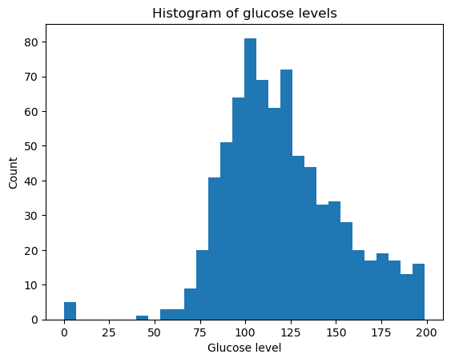
The glucose distribution is right‐skewed, with many values clustering between 80 mg/dL and 140 mg/dL.
Boxplot of BMI by Outcome
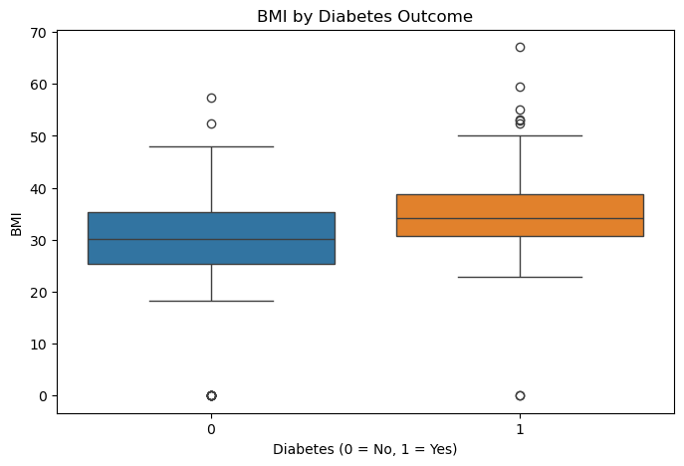
Median BMI for diabetic patients is notably higher (∼33 kg/m²) compared to non‐diabetic patients (∼30 kg/m²). The interquartile range is also shifted upward for diabetics, confirming that obesity is a strong risk factor.
Scatter Plot: Age vs. Glucose (Colored by Outcome)
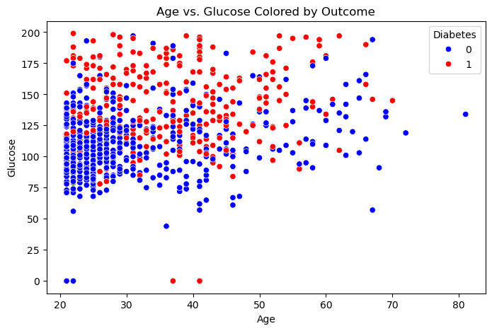
We can see from the scatter plot that there is a correlation between age and glucose levels with diabetic diagnosis.
Overall, our EDA in Milestone 1 confirmed that glucose, BMI, and age are good candidates for model features for predicting diabetic diagnosis.
Milestone 2:
In Milestone 2, we prepared the data for further analysis. We did not drop any features outright because all the provided features may prove useful for prediction. However, we did need to account for missing values. Due to the substantial number of missing values, dropping rows outright would reduce sample size drastically. Instead, we replaced the missing values with the median value for that feature.
In our analysis we found that both insulin and diabetes pedigree function were both heavily right skewed. To account for these, we performed log transformation on these features which can reduce the effect of outliers and help linear model performance. We also engineered the Age feature by creating age bins for the variable. This is because risk of diabetes increases non-linearly with age, so it can be helpful to create bins to try to find certain thresholds in diabetic diagnosis likelihood. We also created a high BMI flag to indicate obesity, which is a well-known risk factor for diabetes.
Milestone 3:
In Milestone 3, we created our model to attempt to predict diabetic diagnosis outcomes. We decided to use a logistic regression model as this model is easy to implement and is effective in binary classification problems. We used the following evaluation metrics to evaluate our model - Accuracy (overall correctness), recall (rate of false negatives), precision (rate of true positive predictions), F1 score (harmonic mean of precision and recall), and ROC-AUC (discrimination ability across all thresholds).
Next, we performed data splitting and preprocessing. This involves dropping the Outcome feature from the main data set and splitting the data in to test and training sets. We used stratification while splitting the data to ensure the same proportion of diabetic/non-diabetic in train and test sets. We then created the pipeline for logistic regression with scaling. The following are the results of the evaluation of our model:
- Accuracy: 0.77
- Precision: 0.71
- Recall: 0.59
- F1 Score: 0.65
- ROC-AUC: 0.83
We found that model correctly identifies ~59% of actual diabetics (recall = 0.59). Of those predicted diabetic, 71% truly have diabetes (precision = 0.71). ROC-AUC of 0.83 indicates strong discrimination. We also plotted the ROC curve, which illustrates the trade-off between true positive rate and false positive rate.
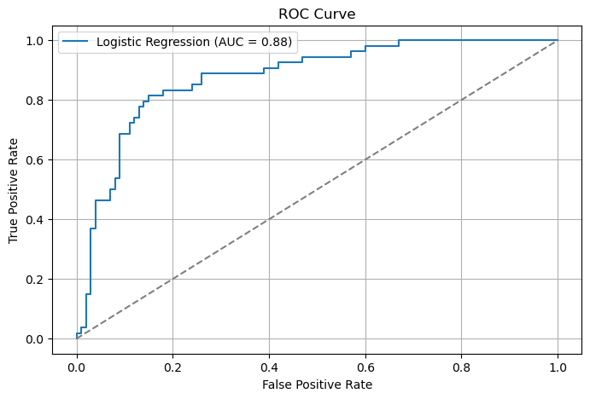
Feature Importance Analysis (added after milestone 3)
We performed feature importance analysis on the logistic regression model to determine which features have the greatest impact on diabetic diagnosis:
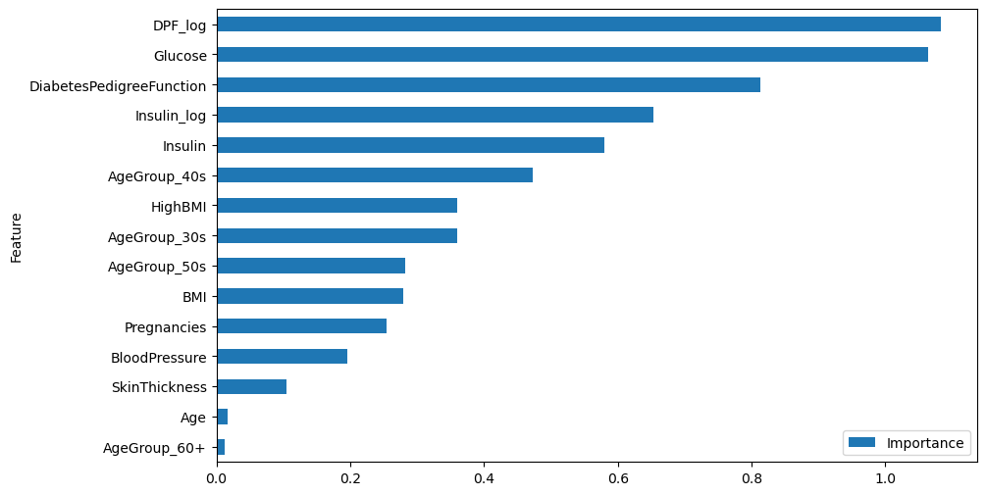
We can see that the log adjusted DiabetesPedigreeFunction has the strongest relationship with the outcome, followed closely by insulin levels. From this we can determine that family history is one of the strongest indicators of diabetic diagnosis, as well as overall insulin levels.
Conclusion:
From our analysis we have determined that a logistic regression model achieves strong predictive performance. While the recall is not as high as we would like to see with a value of 0.59, the ROG-AUC of 0.83 suggests strong predictive performance. From our model we also found that family history and insulin levels are the most influential predictors of diabetic risk.
This model is ready to deploy in real life applications, as it relies on routine measurements that are already recorded in many medical record systems. One point we may recommend to stakeholders would be to pilot test this model in a smaller clinical setting to verify effectiveness. We would also recommend periodic updates to the model training on new data to maintain model effectiveness. It is also important for stakeholders to comply with any privacy, ethical, or legal standards involving patient data.
One potential challenge of this model is that the original dataset is entirely female Pima Indians. To use this model more broadly, we must validate and potentially retrain the model with data from more diverse populations. Another potential challenge is data quality in the real world. In real life applications many medical databases contain missing, erroneous, or outdated entries. An effective production pipeline must be able to gracefully handle these missing values.
Sources
- Kaggle. “Pima Indians Diabetes Database.” https://www.kaggle.com/datasets/uciml/pima‐indians‐diabetes‐database
- UCI Machine Learning Repository. “Pima Indians Diabetes Database.” https://archive.ics.uci.edu/ml/datasets/pima+indians+diabetes

